SOCIAL COGNITIVE ASPECTS OF MENTORING AND BEING MENTORED

SECTION 1: BACKGROUND INFORMATION ABOUT MENTORS/MENTORING
- A mentor is a person who provides advice or trains.
- People have more than one mentor in their lives at any given time.
- Mentors come and go, based on circumstances, and your need.
- It is unhealthy to grow to rely on mentors; it is healthy to turn to mentors who can help you navigate rough waters (especially before the waters get too rough).
Action: Read an expanded definition of “mentor,” as it relates to the social cognitive theories and your motivation. http://www.oycp.com/MentorTraining/3/m3.html

Action: Think of Bandura and Bronfenbrenner, and their ideas about how motivation is effected by social cognitive aspects as you respond to the following prompts.

SECTION 2: MENTOR INTERACTIONS

Action: Write down the names of mentors who have actively helped you in specific areas of your development, preferably within the last 6 months.
- A mentor who helped me with my social development:
- A mentor who helped me with my emotional development:
- A mentor who helped me with my cognitive development:
- A mentor who helped me with my physical development:
- A mentor who helped me with my creative development:

Action: Pick one mentor from the list above who has had a big impact on your development, the one who is “crazy about (you)” (quote from Bronfenbrenner).

Action: Describe one memorable mentoring interaction with this person:

Action: What, as related to the circumstances or timing, made this experience so impactful for you?

Action: What behaviors of your mentor helped you to be receptive to their support? What specifically did they do (or how did they do it) that helped you be more receptive to interacting with them or to taking their advice? (Hint: Do not discuss the advice or insight you gained here; instead reflect about the interaction itself and the behavior of the mentor.)

SECTION 3: MODELING “THERAPY” (see Bandura)

Action: Identify a “stretch” goal you currently have and respond to the following prompts. This can be the same goal you used in Lesson 5 or a new one.

- What is your goal?

- Self-observation: What is the current status of this goal? (Be real.)

- Standards: What is the standard you want to achieve? Is it “just right” for you?

- Self-response: What self-rewards will help you be most successful?
Action: Brainstorm a variety of people you admire, as related to this stretch goal. Consider those in the Microsystem, Mesosystem, or Exosystem. Explain why you admire each of them by filling in the three parts for each of the statements below:

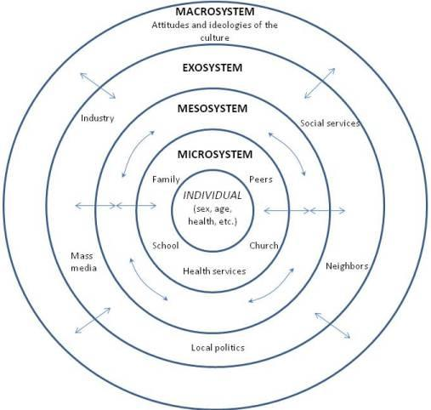

I admire __________ from my ________(micro/meso/exo/macro) system because he/she has the social skills I will need to achieve my goal. What I want to emulate about this person is:
The behaviors of this person that are within my reach are:

I admire __________ from my ________(micro/meso/exo/macro) system because he/she has the emotional stability I will need to achieve my goal. What I want to emulate about this person is:
The behaviors of this person that are within my reach are:

I admire __________ from my ________(micro/meso/exo/macro) system because he/she has the cognitive capabilities I will need to achieve my goal. What I want to emulate about this person is:
The behaviors of this person that are within my reach are:

I admire __________ from my ________(micro/meso/exo/macro) system because he/she has the physical abilities I will need to achieve my goal. What I want to emulate about this person is:
The behaviors of this person that are within my reach are:

I admire __________ from my ________(micro/meso/exo/macro) system because he/she has the creative ways I will need to achieve my goal. What I want to emulate about this person is:
The behaviors of this person that are within my reach are:

SECTION 4: MENTORING

Mentoring Interaction

Action: Provide details of a situation where you believe you were a vicarious (informal, unintentional) mentor to someone who looks up to you. Be sure to include details of who, what, where, when, why, and how.

- What were the reasons this person turned to you (over someone else or in addition to someone else)?

- What behaviors helped supported your mentoring capabilities?

- What mentoring behaviors would you like to get better at?

Vicarious Mentoring

Action: Provide details of a situation where you believe you were a vicarious mentor to someone. Be sure to include details of who, what, where, when, why, and how.

- What were the reasons this person admired you (over someone else or in addition to someone else)?

- What effect did knowing you were/are admired by this person have on your thoughts?

- What effect did knowing you were/are admired by this person have on your behaviors?

